Troubleshooting CoreDNS Pod in Pending State
¹²

When the kubectl get pod coredns pending command shows CoreDNS pods in a Pending state, it indicates that the pods cannot be scheduled or started due to specific issues in the Kubernetes cluster.
Example
$ kubectl get pods -n kube-system
NAME READY STATUS RESTARTS AGE
coredns-558bd4d5db-abcde 0/1 Pending 0 10m
coredns-558bd4d5db-fghij 0/1 Pending 0 10m

Common Causes and Fixes
- Missing CNI Plugin CoreDNS requires a Container Networking Interface (CNI) plugin for networking. If no CNI is installed, the pods will remain pending.
kubectl apply -f https://docs.projectcalico.org/manifests/calico.yaml

- Node Not Ready If nodes are unschedulable or not ready, CoreDNS cannot start.
kubectl get nodes

- Insufficient Resources CoreDNS may fail to schedule if there are insufficient CPU or memory resources.
kubectl describe pod coredns-<pod-name> -n kube-system

- PersistentVolumeClaim Issues If CoreDNS uses a PVC and it is unbound, fix the PVC binding.
kubectl get pvc -n kube-system

- Cluster Initialization Issues Ensure you initialized the cluster with a valid pod network CIDR:
kubeadm init --pod-network-cidr=10.244.0.0/16

By addressing these issues, you can resolve the Pending state of CoreDNS pods and restore cluster functionality.

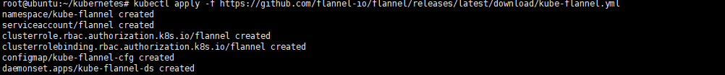
Wait for kube-flannel pods running
